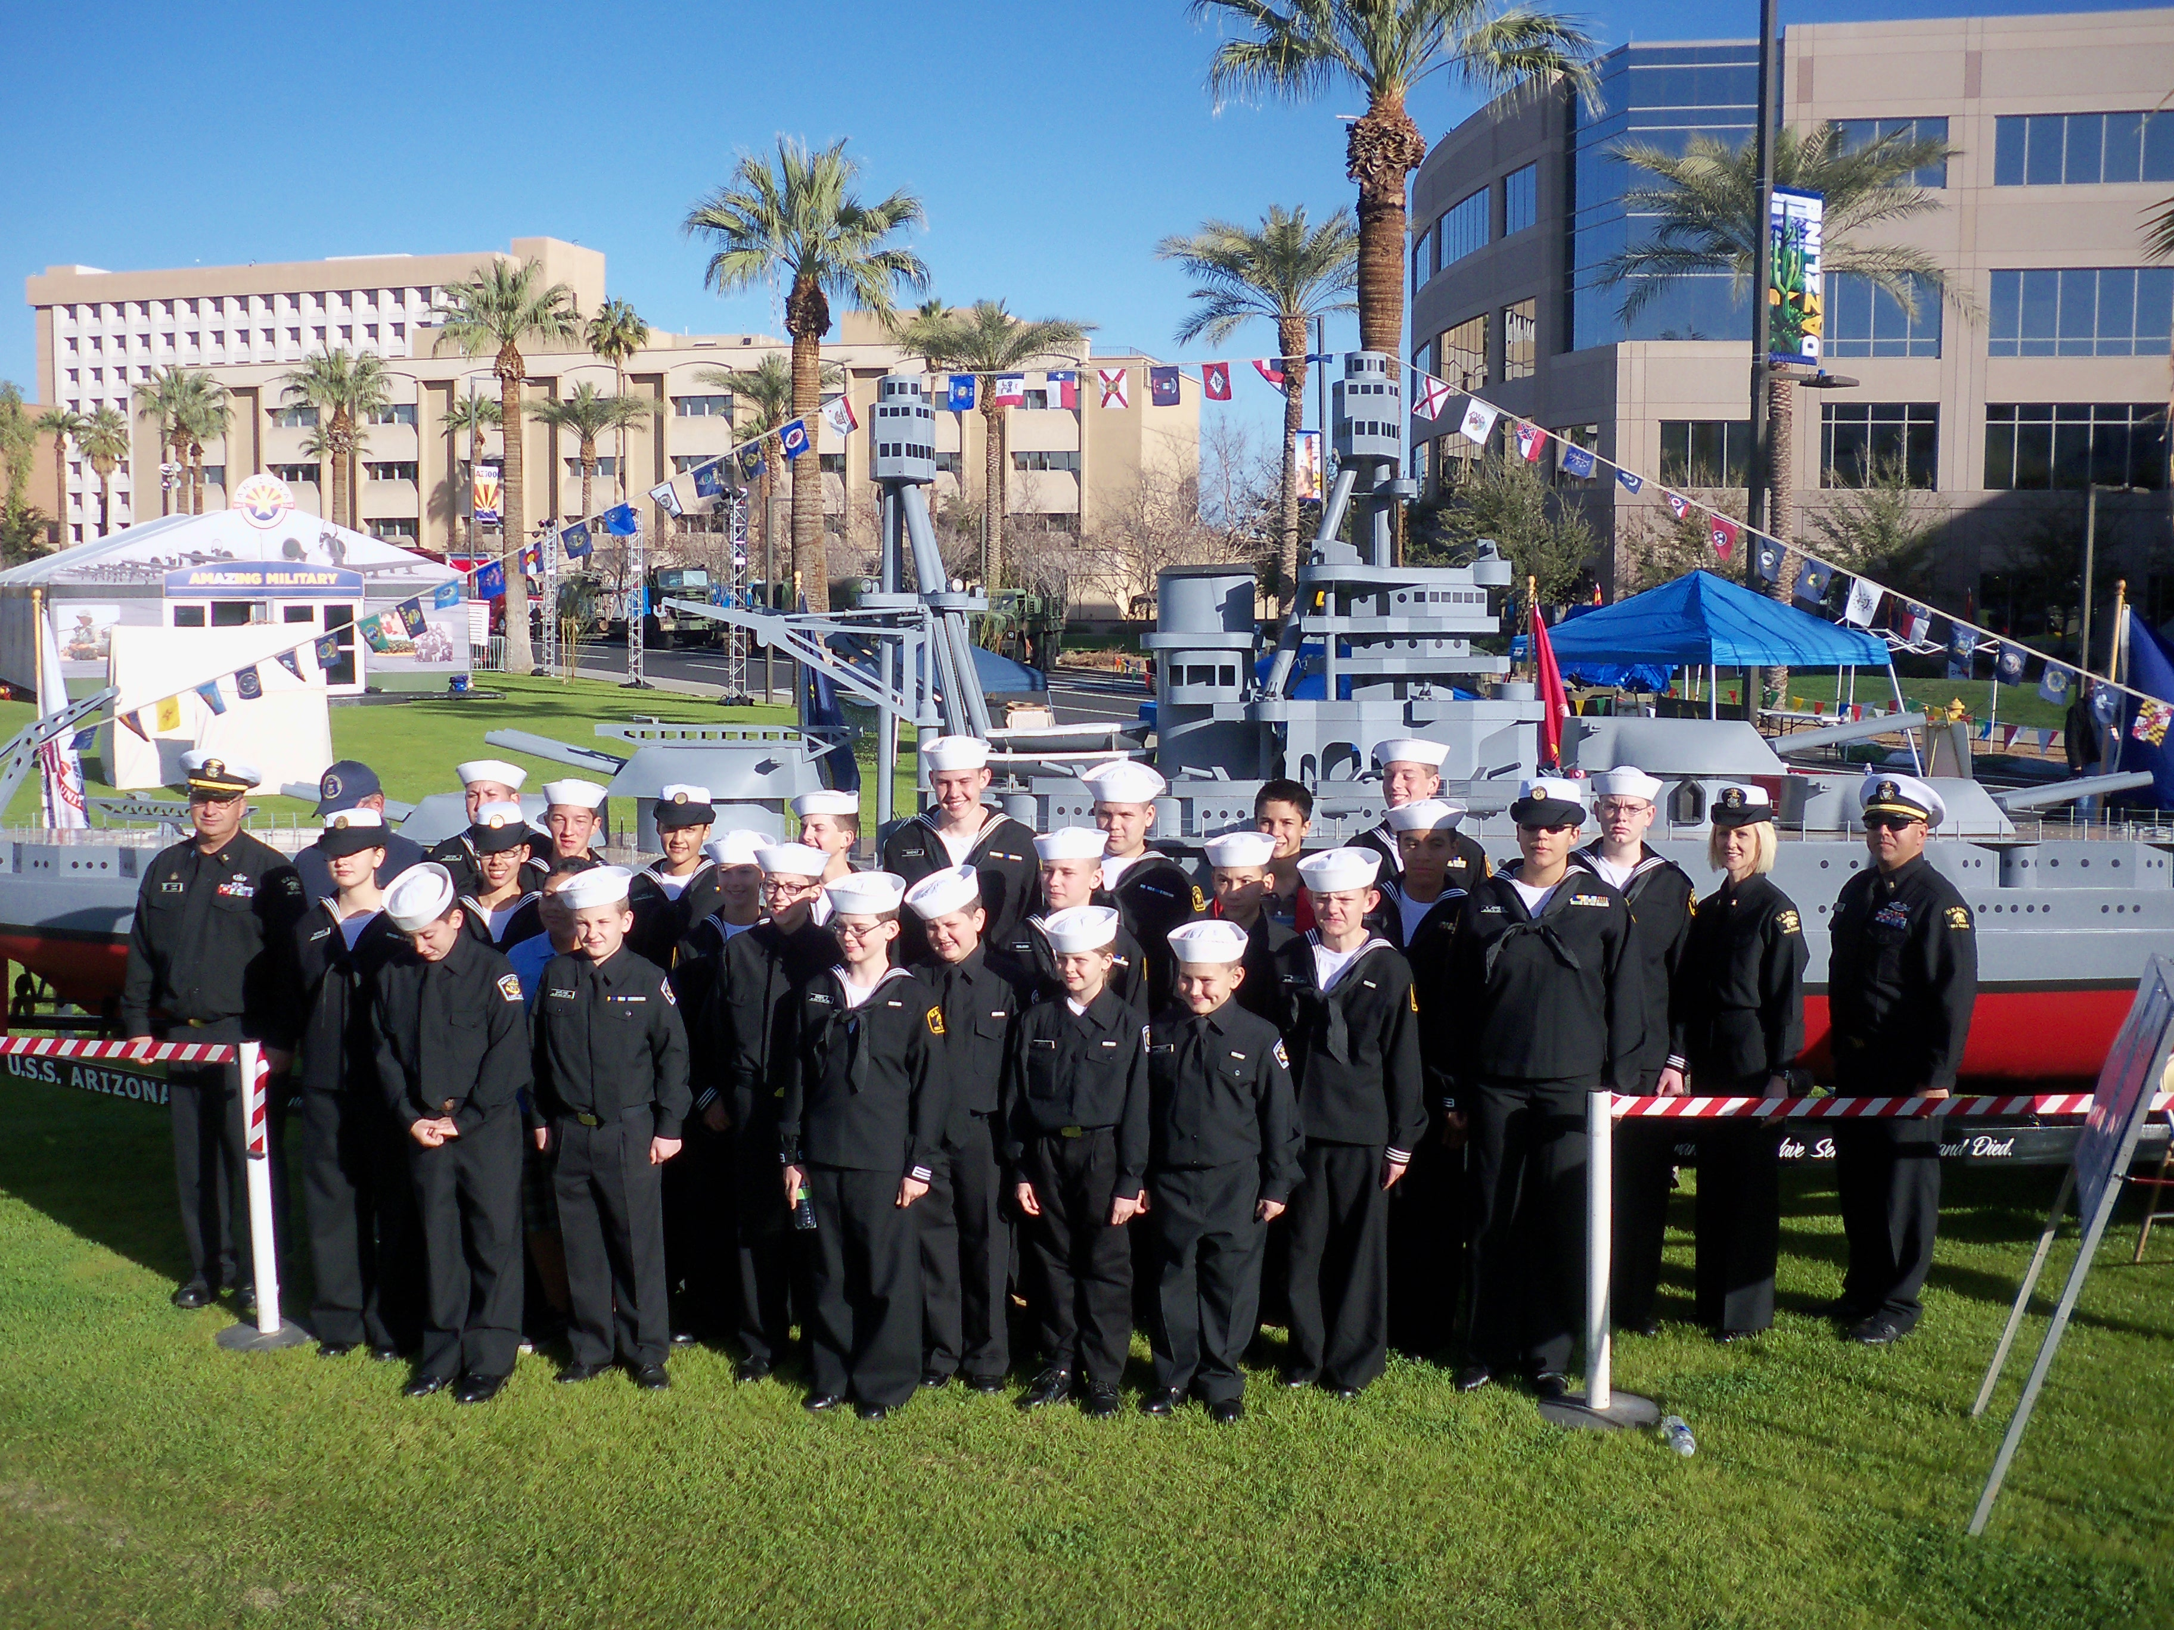
6202 W Myrtle Avenue
Glendale, AZ
United States Sea Cadet Corps

Veteran's Pride Battalion
Welcome Aboard!
Fall 2013
Commanding Officer: LTJG Tomlinson, Dean- USNSCC/USNLCC
Commandingofficer@veteranspride.us
602-478-9459

Executive Officer: Ensign Kaitschuck, Duane- USNSCC/USNLCC
Executiveofficer@veteranspride.us
623-271-0148

Administration Officer: Ensign Tomlinson, DeniseFinancial Officer: Russell, Debbie
602-721-2432

Medical Officer: Ensign Bykerk, LoriBeth, RN/BSNTraining Officer: Russell, Dennis
azsneakysnake@hotmail.com russellsprouts@cox.net
623-341-4980 602-821-5467

Division Officer: Instructor Barnett, CherylSupply Officer: Pierce, Kelly
cheryl.barnett@wesdschools.org

Educational Support: Instructor Riley,
Instructor Nolen, Rick
Senior Chief Morton, Jon

Cadet Leadership:

Ship's Leading Petty Officer:
Petty Officer 3rd Class Obrien, Hunter
United States Naval Sea Cadet Corps

Squad Leader: Seaman Nolen, Ricky
United States Naval Sea Cadet Corps

Squad Leader: Seaman Tomlinson, Nate
United States Naval Sea Cadet Corps

USNLCC Ships Leading Petty Officer:
Petty Officer 1st Class Parham, Jonathon
United States Navy League Cadet Corps

USNLCC Squad Leader:
Eblin,
United States Navy League Cadet Corps
Contact Information:

Phone: Email:

Phone: Email:

Phone: Email:

Phone: Email:

Phone: Email:

Veteran's Pride Battalion
Chain of Command
The USNSCC Promise

“I promise to serve God, Honor our flag, Abide by the United States Naval Sea Cadet Corps
Regulations and carry out the orders of the officers appointed over me, and so conduct
Myself as to be a credit to myself, my unit, the United States Naval Sea Cadet Corps,
The US Navy, the US Coast Guard and my country.”
The Core Values of the United States Navy

Since ancient times, seafarers have known how to navigate by the stars. Although modern navigational instruments have supposedly rendered celestial navigation obsolete, when all of the equipment fails, a trained Sailor can still determine the position of his vessel by reading the stars. He can steer toward his destination using only the information that can be gleaned from the night sky.

To accomplish this minor miracle, the Sailor must first locate three known stars in the sky. Although nearly any known stars will do, a wise Sailor will select three stars that burn brightly; three stars that stand out like beacons against the dark curtain of heaven. By their light, he can measure his own position and set course for his destination.

United States Sailors have three such stars to steer by. We call them our Core Values. They are the three principles by which we can measure our position and set our headings. Honor, Courage and Committment. They are based in the Oath of Enlistment, and are fundamental to the beliefs of the U.S. Navy. As long as we steer by them, we can never be lost.
Honor: “I wil bear true faith and allegiance...”

Courage: “I will support and defend...”

Commitment: “I wll obey the orders...”

The Star Spangled Banner

O! Say can you see by the dawn's early light,
What so proudly we hailed at the twilight's last gleaming,
Whose broad stripes and bright stars through the perilous fight
O'er the ramparts we watched, were so galantly streaming.
And the rockets red glare, the bombs bursting in air,
Gave proof through the night, that our Flag was still there;
O! say does that star-spangled banner yet wave,
O'er the land of the free and the home of the brave.

On the shore, dimly seen through the mists of the deep,
Where the foe's haughty host in dread silence reposes,
What is that which the breeze, o'er the towering steep,
As it fitfully blows, half conceals, half discloses?
Now it catches the gleam of the morning's first beam,
In full glory reflected now shines in the stream:
'Tis the star-spangled banner, O! Long may it wave
O'er the land of the free and the home of the brave.

And where is that band who so vauntingly swore
That the havoc of war and the battle's confusion,
A home and a country should leave us no more!
Their blood has washed out their foul footsteps' pollution.
No refuge could save the hireling and slave
From the terror of flight, or the gloom of the grave:
And the star-spangled banner in triumph doth wave
O'er the land of the free and the home of the brave.

O! thus be it ever, when freemen shall stand
Between their loved home and the war's desolation!
Blest with victory and peace, may the heav'n rescued land.
Praise the Power that hath made and preserved us a nation.
Then conquer we must, when our cause is just,
And this be our motto: “ In God We Trust.”
And the star-spangled banner in triumph shall wave
O'er the land of the free and the home of the brave!
Sailor's Creed

I am a United States Sailor.

I will support and defend the Constitution of the United States of America and I will obey the orders of those appointed over me.

I represent the fighting spirit of the Navy and all who have gone before me to defend freedom and democracy around the world.

I proudly serve my country's Navy combat team with Honor, Courage and Commitment.

I am committed to excellence and the fair treatment of all.
Anchors Aweigh

Navy Boot Camp Version

Stand, Navy, out to Sea, Fight our Battle Cry!
We'll never change our course, so vicious foe steer shy-y-y-y.
Roll out the TNT, Anchors Aweigh! Sail on to victory
And sink their bones to Davy Jones, Hooray!

Anchors Aweigh, my boys, Anchors Aweigh!
Farewell to college joys,
We sail at break of day-ay-ay-ay.
Through our last night on shore,
Drink to the Foam!
Until we meet once more
Here's wishing you a happy voyage home!
The Pledge of Allegiance

I pledge allegiance to the Flag of the United States of America, and the the Republic for which it stands, One Nation, Under God, Indivisible with Liberty and Justice for all.

First Aid:

1. In administering First Aid, your primary task is:

A. Maintaining Breathing
B. Stop Bleeding
C. Prevent or reduce Shock
D. All of the above

2. If unattended, shock can result in death. Bonus: Name the 8 different types of Shock

A. True1. ______________2. _______________
B. False3. ______________4. _______________
5. ______________6. _______________
7. ______________8. _______________

3. What should you never give a person who is going into shock:

A. Water
B. Foot Massage
C. Back Rub
D. All of the above

4. Four steps to control bleeding in proper order are:

A. Direct Pressure, elevation, pressure points, pressure dressing
B. Elevation, tourniquet, pressure dressing, direct pressure
C. Elevation, pressure dressing, direct pressure, tourniquet
D. All of the above

5. What does C-A-B stand for?

A. Circulation, airway, breathing,
B. Aardvark, badger, cookie
C. Trick Question, the proper order is A-B-C.
D. None of the above.
Environmental Injuries

6. The main contributing factors to heat injuries are:

A. Fatigue
B. Weather Conditions
C. Previous heat injury
D. All of the above

7. Which of the following is NOT a type of heat injury:

A. Sunburn
B. Heat Stroke
C. Heat Exhaustion
D. Heat Index

8. Allowing your body to get used to your surroundings is referred to as:

A. Temperature Monitoring
B. Heat Index
C. Acclimatization
D. Hydration

9. Treatment for ALL heat injuries includes which of the following:

A. Immediately evacuate to a hospital
B. Move the victim to a cool place and loosen clothing.
C. Make the victim drink 2 full canteens of water
D. Allow the victim to continue working

10. Heat stroke can result in death if not properly identified and treated.

A. TrueBonus: What is the most dangerous heat emergency?
B. False________________________________________

Swim Qualifications and Safety/Drowning Awareness/Prevention

11. It is a good idea to never swim alone.

A. True
B. False

12. One person should always be designated as a _________________.

A. LifeguardBpnus: What should they have nearby?
B. Water Waiter
C. Water Watcher_____________________________________________
D. Safety Surfer

13. If your ship sinks and you are trying to swim to safety, you should use the ________ stroke.

A. Butterfly
B. Crawl
C. Breast or side
D. Doggy-paddle

14. It is a good idea to wait for about half an hour after eating before going swimming.

A. True
B. False

15. How should you enter the water when you are unsure of the depth?

A. Dive in
B. Sit down and slowly lower yourself into the water
C. Jetty jump
D. None of the above
Visual Communications:

16. The characteristics of a flaghoist are:

A. It is a rapid transmission of the message.
B. It is very accurate.
C. It is for daytime use only.
D. All of the above.

17. The flashing light method uses _____________ to send messages.

A. Voice communication
B. Smoke signals
C. Morse Code
D. Telephone wire

18. Semaphore is ______________.

A. Used at night only
B. The quickest method to send a message
C. Can be used over long distances
D. Used with yardarm blinkers

19. A searchlight can be used for flashing light communications at night.

A. True
B. False

20. One method of visual communication is _______________.

A. Semaphore
B. Telephone
C. Cell Phone
D. Email

21. Another device used to communicate visually is:

A. CD (compact disc)
B. Internet
C. IPAD
D. Banners

Marlinspike Seamanship: Knots & Splices

21. A ______________ keeps the bitter end of a line from pulling through a block or pulley.

A. Square knot
B. Figure eight knot
C. Clove hitch
D. Bowline

22. In general, splices are much stronger than knots.

A. True
B. False

23. Which of the following splices may be used to join two lines together whenever a slight enlargement in line diameter is not very important?

A. Back splice
B. Eye splice
C. Short splice
D. Long splice

24. To shorten a line temporarily, you tie a/an:

A. Overhand knot
B. Becket bend
C. Clove hitch
D. Sheepshank

25. To keep a line from unravelling, you should apply a/an:

A. Splice
B. Eye
C. Whipping
D. Turn

Bonus: What is the most common knot?____________________________--

What is another name for it?____________________________

Basic Seamanship

26. Fittings on the deck of a ship through which mooring lines are led are called ___________.

A. Rat guards
B. Bitts
C. Chocks
D. Hawespipe

27. The term “trim” refers to:

A. Everything left of the centerline when facing forward
B. The relationship between fore and aft draft
C. The distance from the waterline to the weather deck
D. The in-port watch station for the OOD

28. The term “starboard” refers to:

A. An imaginary line running from bow to stern
B. The after most part of a ship
C. Everything to the right side of the centerline
D. Everything to the left side of the centerline

29. When ships are in port, they are moored to:

A. The vertical windlass
B. Fenders
C. An anchor
D. Another ship or a pier

30. The port or starboard incline of a vessel is referred to as ____________.

A. TrimBonus: What is the easiest way to remember the difference between
B. List Port and Starboard?
C. Draft_______________________________________________________
D. Freeboard_______________________________________________________
_______________________________________________________
_______________________________________________________

Damage Control, FireFighting & Fire Chemistry

31. All compartments on a ship are water tight.

A. True
B. False

32. Which of the following is not an element of the fire tetrahedron:

A. Fuel
B. Chemical Chain Reaction
C. Water
D. Heat

33. The most widely used extinguishing agent for a Class A fire is:

A. AFFFBonus: Why?
B. PKP________________________________________
C. Sodium Bicarbonate________________________________________
D. Water________________________________________

34. Burning metal (like magnesium or titanium) or other hazardous material is what class of fire?

A. Class A Bonus: What is the most widely used extinguishing agent for
B. Class B this type of fire?
C. Class C
D. Class D________________________________________________

35. An electrical fire is what class of fire? Bonus: What extinguishing agent is preferred?

A. Class A_________________________________________________
B. Class B
C. Class C
D. Class D

36. What is the most important thing when responding to an emergency situation?

A. Making sure you are in the correct uniform
B. Remaining calm and being able to see the “big picture”
C. Making sure the scene is safe
D. B and C

37. What are the two most common diameters of firehose?

A. 1” and 2”
B. 1.5” and 2”
C. 1.75” and 2.5”
D. 1 1/2” and 2 1/2”

38. Name the positions of the firefighters on a hoseline:

A. Lineman, Hoseman, NozzlemanBonus: Who runs the engine?
B. Nozzleman, Officer, Hoseman
C. Nozzleman, Hoseman, Officer____________________________
D. Hoseman, Officer, Nozzelman

39. When fighting a Class C fire, what is the first thing you do?

A. Secure the powerBonus: What is a Class C fire?
B. Close the door
C. Cover it with water_______________________________________
D. None of the above

40. What is the standard length of fire hose? Bonus: Why?

A. 25 feet_______________________________________________
B. 50 feet _______________________________________________
C. 75 feet _______________________________________________
D. 100 feet _______________________________________________
_______________________________________________
_______________________________________________

Drug Abuse- Zero Tolerance

41. The term “Zero Tolerance” as it refers to the US Navy and USNSCC's policy on drug use and abuse means that:

A. Dismissal will occur on the first offense.
B. Dismissal will occur on the third offense.
C. Dismissal will occur on an individual basis.
D. Captains Mast with the outcome decided upon by Command

42. Which of the following additional types of discipline are likely to occur if you are found guilty of a drug offense in the US Navy:

A. Jail time or criminal record
B. Captain's Mast
C. Discharged under “Other than Honorable” conditions
D. All of the above

43. All effects of drug use are reversible if you only try drugs once or twice.

A. TrueBonus: What is the number for Poison Control?
B. False
_____________________________________

44. A drug which causes hallucination, mood swings, and long lasting psychosis is:

A. Inhalants
B. LSD
C. Cocaine
D. Marijuana

45. Use of smokeless tobacco or “chewing tobacco” is not as harmful as smoking cigarettes.

A. True
B. False

Sexual Harassment, Hazing & Fraternization

46. Sexual Harassment is a form of sexual discrimination that must meet three criteria. The behavior must:

A. Be unwelcome
B. Be sexual in nature
C. Occur in, or have some impact on the US Navy or USNSCC environment
D. All of the above

47. Using one's sex or sexuality to obtain special rewards or favors is called _______.

A. Sexual Harassment
B. Sexual Discrimination
C. Reprisal
D. Sexual Politics

48. Touching a cadet in order to assist them with Physical Training, their uniform or some other USNSCC activity is ALWAYS sexual harassment.

A. TrueBonus: What are the US Navy's Core Values?
B. False
____________, _________________, ______________________

49. Sexual Harassment is prohibited in the USNSCC and the US Navy because it:

A. Causes hard feelings between shipmates
B. Is harmful to morale
C. Interferes with productivity
D. All of the above

50. A relationship between seniors and subordinates that is unduly familiar and does not respect differences between rank or grade is __________________.

A. Sexual Harassment
B. Sexual Politics
C. Flirting
D. Fraternization
Historical Navy Uniforms, USNSCC Uniforms & Uniforms/Grooming Standards

51. Which of the following is the purpose of the design of US Navy uniforms both historically and today?

A. All of the below answers
B. Characterizes many of the Navy's traditions
C. Provides protection against the elements
D. Marks you as a professional and a member of the military service

52. Originally, the US Navy Uniforms were based on the design of British Naval Officer's Uniforms.

A. TrueBonus: Who is the Commander in Chief of the US Navy?
B. False
_______________________________________

53. The name for today's US Navy enlisted working uniform was derived from the name “dungree”, which referred to discared cloth from ships sails.

A. TrueBonus: What is another US Navy slang term for NWU's?
B. False
____________________________________________

54. The proper hairstyle for female cadets/sailors who have long hair, while in uniform is:

A. A ponytail
B. A bun or braid, secured so it does not fall below the collar
C. Hair pulled back into a clip
D. None of the above

55. Sea Cadets are permitted to wear mustaches in uniform, provided they are properly groomed and cared for.

A. TrueBonus: How are sailors trained to cut hair in the US Navy?
B. False
______________________________________________________________________________________________________________________________________________________________________________________________________________________________________________________________________________________________________________________________________________________________

56. The nametape is worn over which pocket on the working uniform?

A. Right
B. Left
C. Both
D. None of the above

57. The US Navy uniforms are modified for Sea Cadets primarily by wearing what additional items?

A. Neckerchief
B. USNSCC/USNLCC Flashes on the shoulders
C. Rank in different locations
D. None of the above

58. How far down from the shoulder seam does the USNSCC/USNLCC flash go?

A. 3”
B. Centered between the shoulder and elbow
C. 1”
D. 1/2”

59. One necklace may be worn while in uniform, provided it is not visible.

A. TrueBonus: Why do sailors wear dog tags?
B. False__________________________________________________
__________________________________________________
__________________________________________________
__________________________________________________
__________________________________________________

60. USNSCC Cadet rank insignia is worn in which of the following locations?

A. On the right sleeve, below the USNSCC flash
B. Pinned onto the collar
C. On the left sleeve, below the USNSCC flash
D. None of the above

Interior Communications

61. There are no ships in the Navy that still use the voice tube method of communication.

A. TrueBonus: Are cell phones used to communicate on ship?
B. False__________________________________________________

62. What is the biggest disadvantage of the Ship's Service Telephone?

A. It cannot communicate with all parts of the ship
B. The number of talkers it can reach at a time is small
C. The ship cannot be connected to landlines while in port
D. None of the above

63. The shipboard announcing system in the Navy is referred to as the:

A. BCMBonus: What is the sailors favorite way to communicate with
B. BM their family while on board ship?
C. MC
D. MIC_____________________________________________________

64. Where on board a ship can transmitters for the IMC be found?

A. BridgeBonus: Name the officers on the Quarterdeck...
B. Quarterdeck
C. Central Station__________________________ ____________
D. All of the above__________________________ ____________

65. Sound powered telephones require external power in order to function properly.

A. TrueBonus: Morse Code was invented by whom and is it still used today?
B. False
________________________________________________________
________________________________________________________
________________________________________________________
________________________________________________________
Tell me and I will forget, Show me and I may remember, but involve me and I will understand”
– Chinese proverb

